PROJECT REPORT
ON
BOX AC WITH WATER-LEVEL INDICATOR


DHARMSINH DESAI UNIVERSITY
FACULTY OF TECHNOLOGY
DEPARTMENT OF ELECTRONICS AND COMMUNICATION

PREPARED BY: GUIDED BY:
Vivek Baku (EC-004), Sem V Prof. Nisarg k. Bhatt
Rahul Baldaniya (EC-005), Sem V

CERTIFICATE

This is to certify that the project on BOX AC WITH WATER-LEVEL INDICATOR and term work carried out in the subject of Term Project is bonafide work of VIVEK BAKU (Roll no.: EC-004) and RAHUL BALDANIYA (Roll no.: EC-005) of B. Tech. semester V in the branch of Electronics & Communication, during the academic year 2019-20.
Prof. Nisarg K Bhatt | Dr. Nikhil J. Kothari
Project Guide, EC Dept. | HOD, EC Dept.

ACKNOWLEDGEMENT

It is pleasant task to express our gratitude to all those who have accomplished and helped us in this work.

First and foremost, we take this opportunity to express deep sense of gratitude to our guide Prof. Nisarg K. Bhatt, Department of Electronics and Communication, Dharmsinh Desai University, Nadiad, for his valuable suggestions and encouragement throughout the project which helped us a lot to improve this project work. We are also indebted to Dr. Nikhil J. Kothari, HOD of Electronics and Communication, Dharmsinh Desai University, Nadiad, for their kind help and co-operation during this work.

Last but not least, we extend our thanks and appreciation to our friends, colleagues, batch-mates and everyone who have helped us directly or indirectly to get this work done.

ABSTRACT

In today’s world, there is a continuous need for automatic as well as portable appliances with increase in standard of living. We designed a Box AC with water level measurement which can be used in a less space of work. Thus we have come up with an idea of reducing the standby power and designed a box AC that is safe and portable.
The Box AC provides you cold air from the vent after supplying it ice. The ice gets melted from the upper section to lower tank where a water level indicator is present.
Water level indicator is a simple low cost circuit. The circuit is made with various components like transistors (BC547), Resistors, Leds etc. At last after discussions and help from our teacher we came to this simple circuit which is cheap and easily installable. The other circuits which we have seen were very critical than this circuit.
The operation of water level indicator works upon the fact that water conducts electricity. So water can be used to signal the level by using the LEDs at different levels.

INDEX

Sr. No. | Title | Page No.
1 | Introduction | 6
2 | Block Diagram | 7
3 | Circuit Diagram | 8
4 | Component Description | 9
5 | Working of Circuit | 14
6 | Practical Setup and Trouble Shooting | 15
7 | Conclusion | 16
8 | References | 16

1. INTRODUCTION

Due to rising of temperature in everyday life, everyone needs appliances which provide them coolness like AC, cooler etc. But not everyone could afford it or one who can afford can’t have enough space to fit in a particular space. Therefore we came up with an idea of a Box AC, small, cheap and portable device. The Box AC provides simple mechanism of cooling the atmosphere by melting the ice with a 12V DC supply exhaust fan present in the upper section. This also has a water level indicator present as the ice melts.

The water level indicator employs a simple mechanism to detect and indicate the water level in the tank after ice melts from the upper section. The sensing is done by using a set of four probes which are placed at four different levels in the tank. The RED LED indicates the ice is completely melted. After that you need to fill up the ice again in upper section.
Most water level indicators are equipped to indicate and detect only a single level. The Water Level Indicator implemented here can indicate up to four such levels and the Led’s shows the level number. So, not only is the circuit capable of cautioning a person that the water tank has been filled up to a certain level, it also indicates that the water level has fallen below the minimum detectable level.
In this project we show the water level indicator using four transistors which conducts as level rises.

2. BLOCK DIAGRAM
POWER
SUPPLY
DC
FAN
MELTING
OF ICE
WATER
TANK
CIRCUIT

3. CIRCUIT DIAGRAM

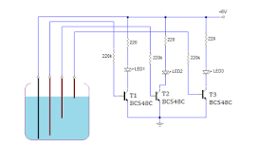
Fig. 3.1 Water Level Indicator
4. COMPONENTS AND IT’S DESCRIPTION

  - TRANSISTOR (BC547)
BC547 is npn bipolar transistor. A transistor stands for transfer of resistance, it is commonly used to amplify current. It is mainly used for switching and amplifying purposes. It has maximum current gain of 800. Its equivalent transistors are BC548 and BC549. The transistor terminals require a fixed DC voltage to operate in the desired region of its characteristic curves. For switching applications, transistor is biased so that it remains fully on if there is a signal at its base. In the absence of base signal, it gets completely off.

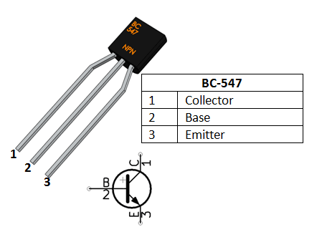
Fig 4.1 Transistor (BC547)

4.2 DC AXIAL COOLING FAN (12V)
Dc axial cooling fan axial fans blow air along the axis of the fan, or parallel to the track of the blade axis. Dc axial fans are found in a variety of applications, including computing, servers, telecommunication cabinets, and any type of equipment where the need for thermal control is necessary for the improved reliability and life extension of the components that are included in the system.

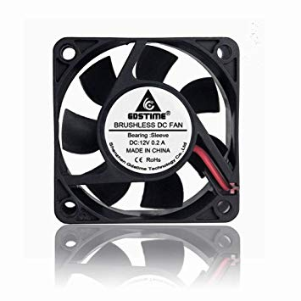

Fig.4.2 DC Axial cooling fan

  - LED’s
LEDs, are real unsung heroes in the electronics world. They do dozens of different jobs and are found in all kinds of devices. Among other things, they form numbers on digital controls, transmit information from remote controls light up watches and tell you when your appliances are turned on. Basically, LEDs are just tiny light bulbs that fit easily into an electrical circuit.
A Light Emitting Diode (LED) is a semiconductor diode that emits light when an electric current is applied in forward direction of the device as in simple LED circuit. The effect is a form of electroluminescence where incoherent and narrow-spectrum light is emitted from the p-n junction.
.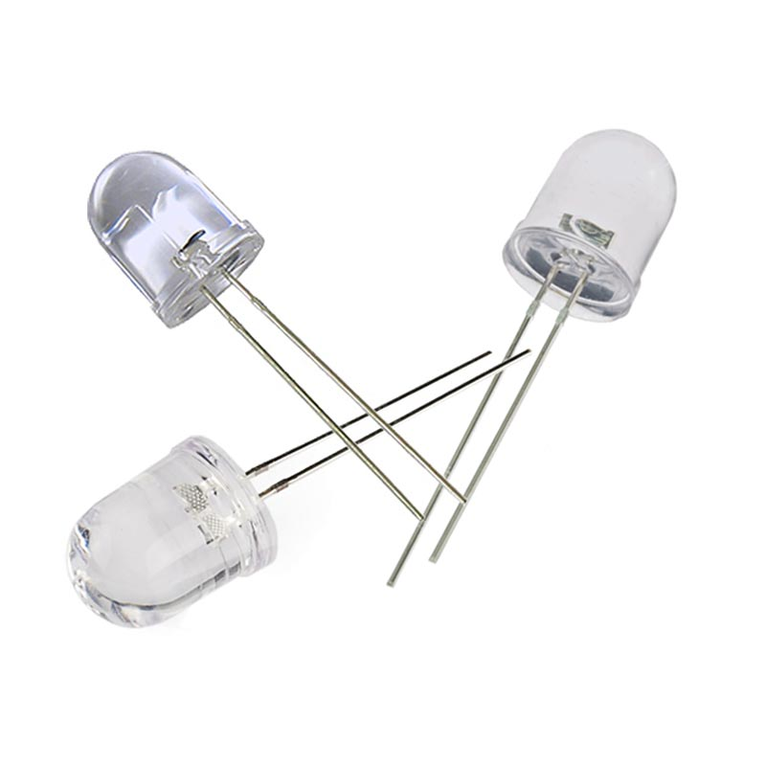
Fig.4.3 LED (Light Emitting Diode)

  - RESISTORS (220 Ω)
A resistor is a passive two-terminal electrical component that implements electrical resistance as a circuit element. Resistors act to reduce current flow, and, at the same time, act to lower voltage levels within circuits. In electronic circuits, resistors are used to limit current flow, to adjust signal levels, bias active elements, and terminate transmission lines among other uses.

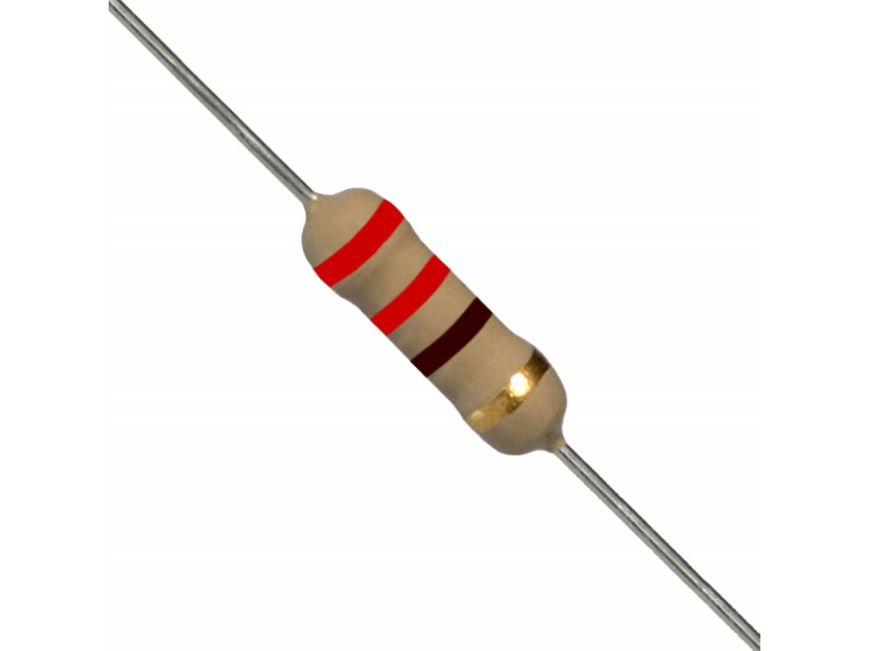

Fig.4.4 Resistor (220 Ω)

  - Battery (9V)
Battery is a device consisting of one or more electrochemical cells with external connections provided to power electrical devices such as flashlights, mobile phones, and electric cars. When a battery is supplying electric power, its positive terminal is the cathode and its negative terminal is the anode.
When the anode and cathode of a battery is connected to a circuit, a chemical reaction takes place between the anode and the electrolyte. This reaction causes electrons to flow through the circuit and back into the cathode where another chemical reaction takes place.

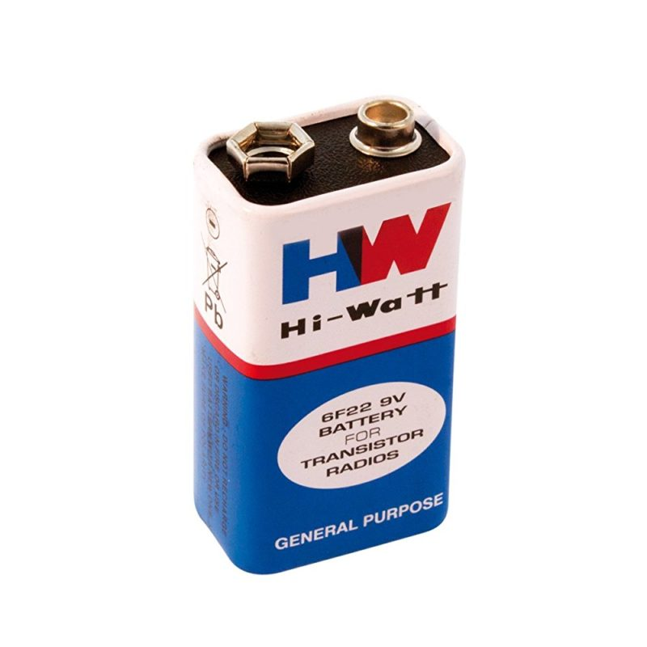
Fig.4.5 Battery (9V)

5. WORKING OF CIRCUIT

Basically the body of the project is divided into two parts:
- Upper Section
- Lower tank

- Upper section consists of a DC axial cooling fan and a aluminium jar on which the ice will be placed. The DC fan is further connected with a constant 12V DC Power supply. As the supply is provided to the fan the ice melts as the air comes in contact with it. Due to it cool air is blown through the vent of the upper section. But the main mechanism is that it is connected with the lower tank.

- The lower tank consists of a Water level indicator system. Now as the ice is melted the water starts getting collected at the base of the tank. When the water starts filling in water tank then the yellow led glows, next when the water reaches upto the mid level of the water tank then blue led glows indicating the tank is half filled. After that the red led glows indicating that the tank is going to be full and your ice is completely melted. So red led gives you the indication to supply the ice to keep the AC process ongoing.

6. PRACTICAL SETUP AND TROUBLESHOOTING

During the working with the project we faced several problems:-
- The power supply we were using was not giving the constant output so due to that transistors and Led’s were blown out.

- The another issue was that the voltage across the collector and base of the transistor (BC547) was continuously varying.

- Thus we altered our calculations and changed the following necessary components and got the desired output.

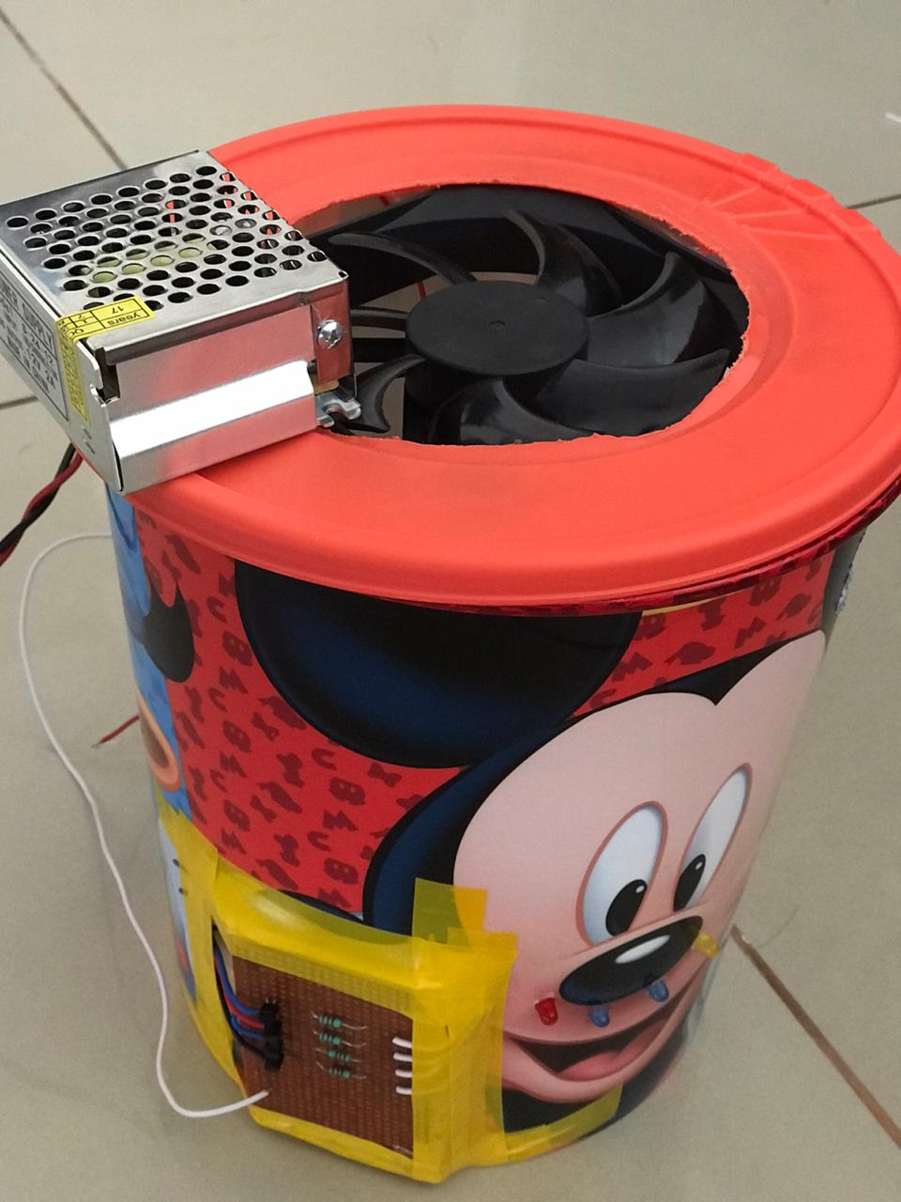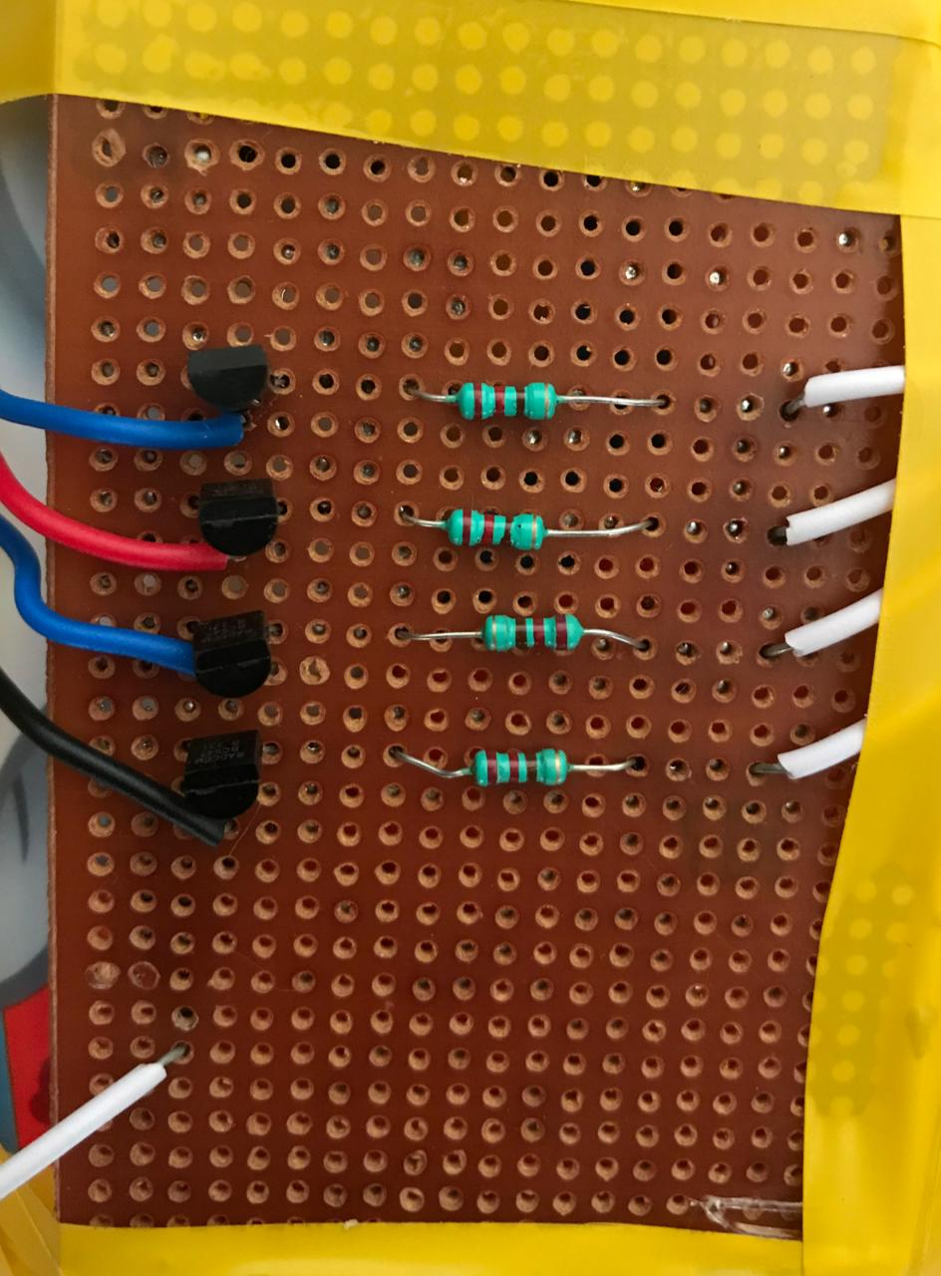

Fig 6.1 Project model and Circuit

7. CONCLUSION

The Box AC with water level Indicator employs a simple mechanism to detect and indicate the water level in an over head tank or any other water container. Its simplicity in design and low cost components make it an ideal piece of technology for the common man. During the testing of the circuit the led’s were not glowing properly, so we have make sure that proper biasing of the transistor should be done.

8. REFERENCES

- https://components101.com/
- https://youtu.be/8oF_6Tjz9CE
- https://www.wikipedia.org
- https://www.alldatasheet.com/datasheet-pdf/pdf/16101/PHILIPS/BC547.html

